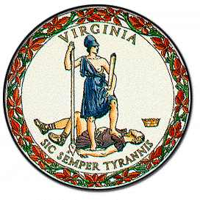
FOR IMMEDIATE RELEASE
Monday, January 11, 2021
Contact: Henry Watkins
Office of Senator Adam Ebbin
henry@adamebbin.com
703-646-0591

SENATOR ADAM EBBIN, DELEGATE PAUL KRIZEK SEEK STATE FUNDING FOR PRESERVATION OF RIVER FARM

Delegate Paul Krizek (D-Mount Vernon) and Senator Adam Ebbin (D-Alexandria) have proposed budget amendments to allocate $2 million for a state fund for the preservation of the historic River Farm property for public use and enjoyment. The funds would assist the Northern Virginia Conservation Trust and the Northern Virginia Regional Park Authority to purchase the property at fair market value, and preserve it as open space for public enjoyment.

Delegate Krizek and Senator Ebbin earlier this year gathered over 1,000 petition signatures from concerned residents which they delivered to the American Horticultural Society, urging the organization to ensure that the property be preserved as public space, and serve as Partners to the Save River Farm Committee, a grassroots organization working to preserve the land.

River Farm, which comprises 25 acres of publicly accessible green space on the Potomac River, served as the headquarters for the American Horticultural Society (AHS) since 1973. In August 2020, AHS announced their intent to sell the property on the open real estate market. Following an outflow of public support, the Northern Virginia legislators devised a solution that would allow continued preservation of the land.

“I’m hopeful that Del. Krizek and I will be able to bring funding to assist our local partners, so that River Farm can be enjoyed by generations to come.” said Senator Ebbin.

““River Farm has operated for years as a wonderful public space and events venue for our community, and we are committed to keeping this invaluable and historic resource open for the public to continue to enjoy. Long into the future” added Delegate Krizek.

River Farm, which was the northernmost of George Washington's Five Farms, represents the largest remaining property on the Potomac owned by General Washington. Should the budget amendments pass, the funds would be used to to keep the land open to the public in perpetuity.

###

